*Data-Driven Recommendations to Cut Costs and Increase Revenue*

**RECOMMENDATIONS:**

1. **Increase Ticket Prices for Adult Weekend Tickets**

Our predictive model suggests a ticket price of **$95.87** based on the current prices set by the other resorts within our dataset.

1. **Close Down 1 of the 10 Least Used Runs**

This will help reduce overall operating costs, while our analysis indicates that doing so **will not** reduce support for ticket prices or revenue.

1. **Increase Vertical Drop by Adding Additional Run, Chairlift.**

By making these changes, our model indicates an increased support for ticket prices and subsequently an increase in revenue.

**ANALYSIS:**

Based on our modeling of the information provided, the resort has been undercharging for their adult weekend tickets and limiting its earning potential. At the current ticket price of $81.00, Big Mountain sits on the higher end compared to most other resorts.

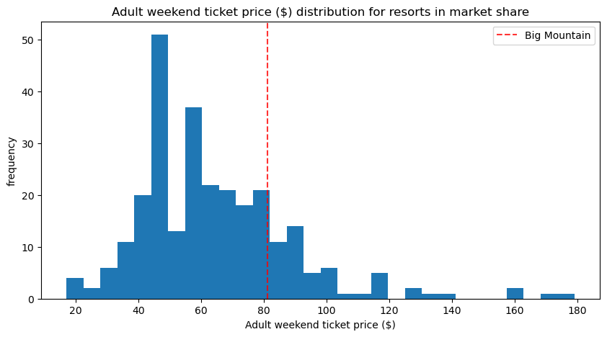

However, Big Mountain resort also has above average features and facilities that consumers are willing to pay higher ticket prices for including:

*Vertical Drop*

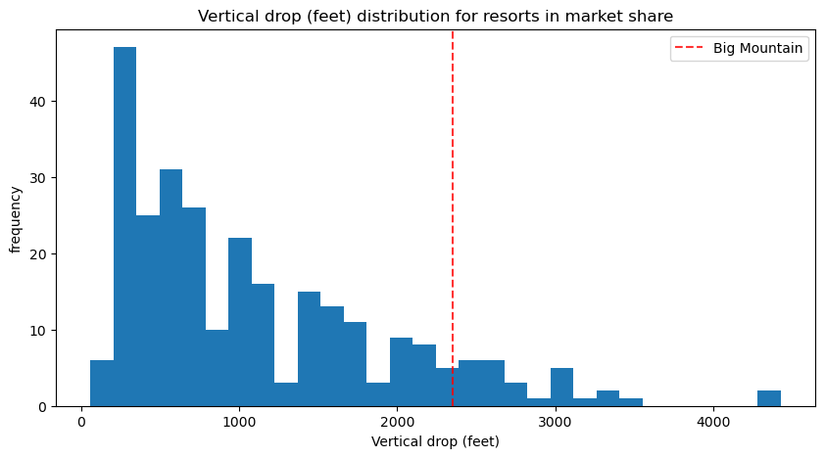

*Snow Making Area*

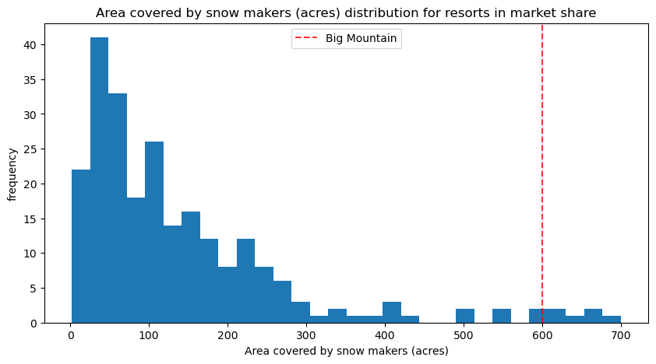

*Total Runs and Longest Run Length*

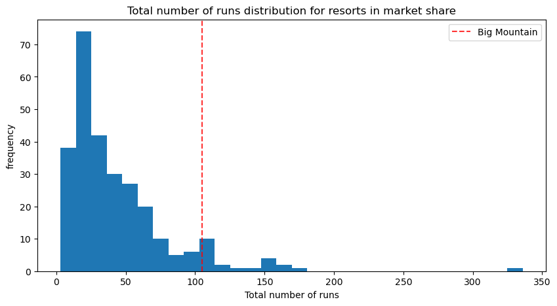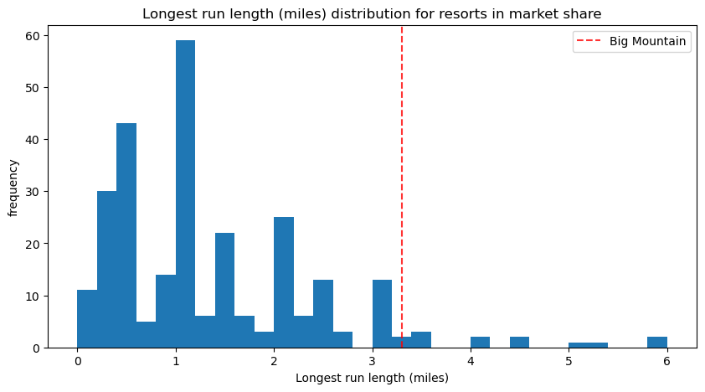

A resort with facilities of this quality should be charging higher ticket prices. This reinforces the higher modeled price obtained through our predictive model, and has the opportunity to increase revenue without any other changes. Our analysis of the options provided to us indicated that there were two additional avenues to cut costs and increase revenue. We found that closing down one of the ten least popular runs had **no effect** on support for ticket prices or overall revenue as shown in the figure below. Closing additional runs **did** have a negative impact, so our recommendation is to **close only a single run**. This will reduce operating costs, and/or allow for a reallocation of capital to features that have a better ROI.

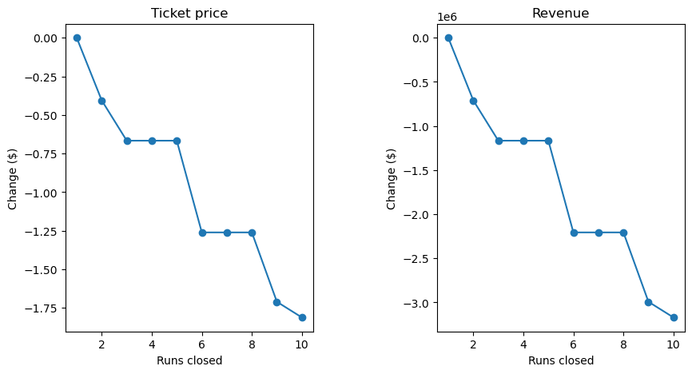

The second scenario from the shortlisted options and our final recommendation is to add an additional run to increase vertical drop by 150 feet, and install an additional chairlift to accommodate this. Our model predicted that these changes would **increase support for ticket prices by $8.61** which over the course of the season would amount to **$15,065,471**.

**CONCLUSION:**

We believe that by making these changes, Big Mountain Resort has the opportunity to both reduce some of their operating costs as well as increase ticket prices and therefore revenue.